1
ETU-LINKNK
Optical Communication System
SFP

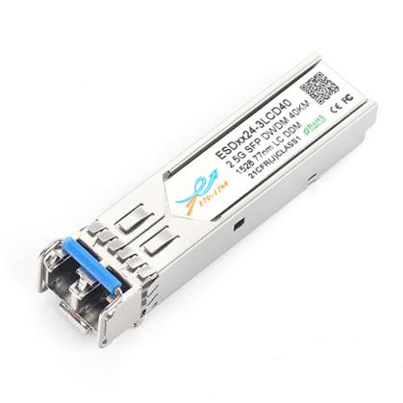
ESDxx24-3LCD40
2.67Gbps DWDM 40KM SFP Transceiver Reach
- Wavelength selectable to C-band ITU-T grid wavelengths
- Suitable for use in 100GHz channel spacing DWDM systems
- DWDM SFP MSA Compliant
- Dual data-rate of 2.67Gbps/1.25Gbps/1.063Gbps operation
- OC-48 40KM range
- Up to 2.67Gb/s data rate
- Cold Start up Wavelength Compliance
- Low Power Dissipation <1.3W Maximum
- -5ºC to 70ºC Operating Case Temperature
- Diagnostic Performance Monitoring of module temperature, supply
Voltages, laser bias current, transmit optical power, receive optical power,
Laser temperature and TEC current
- Extended link budget with PIN receiver technology
- RoHS compliant and lead free

Applications

- SFP Transceivers for DWDM SONET/ SDH
- Ethernet IEEE 802.3ae
- Fiber Channel

Description
ETU-Link DWDM SFP Transceiver exhibits excellent wavelength stability, supporting operation at 100 GHz channel, cost effective module. It is designed for DWDM SONET/ SDH, Gigabit Ethernet and Fiber-
Channel applications.
The transceiver consists of two sections: The transmitter section incorporates a cooled DFB laser. And the receiver section consists of an PIN photodiode integrated with a TIA. All modules satisfy class I laser safety requirements. ETU-Link DWDM SFP transceiver provides an enhanced monitoring interface, which allows real-time access to device operating parameters such as transceiver temperature, laser bias current, transmitted optical power, received optical power and transceiver supply voltage, laser temperature and TEC current.
Pin Descriptions
2

Pin | Symbol | Name/Description | NOTE
1 | VEET | Transmitter Ground (Common with Receiver Ground) | 1
2 | TFAULT | Transmitter Fault.
3 | TDIS | Transmitter Disable. Laser output disabled on high or open. | 2
4 | MOD_DEF(2) | Module Definition 2. Data line for Serial ID. | 3
5 | MOD_DEF(1) | Module Definition 1. Clock line for Serial ID. | 3
6 | MOD_DEF(0) | Module Definition 0. Grounded within the module. | 3
7 | Rate Select | No connection required | 4
8 | LOS | Loss of Signal indication. Logic 0 indicates normal operation. | 5
9 | VEER | Receiver Ground (Common with Transmitter Ground) | 1
10 | VEER | Receiver Ground (Common with Transmitter Ground) | 1
11 | VEER | Receiver Ground (Common with Transmitter Ground) | 1
12 | RD- | Receiver Inverted DATA out. AC Coupled
13 | RD+ | Receiver Non-inverted DATA out. AC Coupled
14 | VEER | Receiver Ground (Common with Transmitter Ground) | 1
15 | VCCR | Receiver Power Supply
16 | VCCT | Transmitter Power Supply
17 | VEET | Transmitter Ground (Common with Receiver Ground) | 1
18 | TD+ | Transmitter Non-Inverted DATA in. AC Coupled.
19 | TD- | Transmitter Inverted DATA in. AC Coupled.
20 | VEET | Transmitter Ground (Common with Receiver Ground) | 1

Notes:
- Circuit ground is internally isolated from chassis ground.
- Laser output disabled on TDIS>2.0V or open, enabled on TDIS<0.8V.
- Should be pulled up with 4.7k - 10kohms on host board to a voltage between 2.0V and 3.6V.MOD_DEF (0) pulls line low to indicate module is plugged in.
- This is an optional input used to control the receiver bandwidth for compatibility with multiple data rates (most likely Fiber Channel 1x and 2x Rates).If implemented, the input will be internally pulled down with > 30kΩ resistor. The input states are:
Low (0 – 0.8V): Reduced Bandwidth
(>0.8, < 2.0V): Undefined
High (2.0 – 3.465V): Full Bandwidth
3
Open: Reduced Bandwidth
- LOS is open collector output should be pulled up with 4.7k - 10kohms on host board to a voltage between 2.0V and 3.6V. Logic 0 indicates normal operation; logic 1 indicates loss of signal.
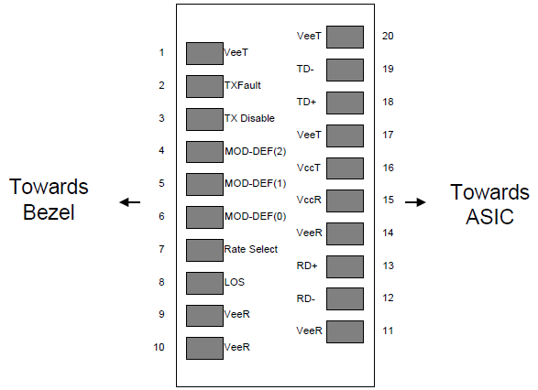
Figure2. Pin out of Connector Block on Host Board
Absolute Maximum Ratings
Parameter | Symbol | Min. | Typ. | Max. | Unit | Note
Storage Temperature | Ts | -40 |  | 85 | ºC
Relative Humidity | RH | 5 |  | 95 | %
Power Supply Voltage | VCC | -0.5 |  | 4 | V
Signal Input Voltage |  | -0.3 |  | Vcc+0.3 | V
Receiver Damage Threshold |  | +5 |  |  | dBm

Recommended Operating Conditions
4
Parameter | Symbol | Min. | Typ. | Max. | Unit | Note
Case Operating Temperature | Tcase | 0 |  | 70 | ºC
Power Supply Voltage | VCC | 3.13 | 3.3 | 3.47 | V
Power Supply Current | ICC |  |  | 500 | mA
Power Supply Noise Rejection |  |  |  | 100 | mVp-p | 100Hz to 1MHz
Data Rate |  |  | 2500/2500 | 2670 | Mbps | TX Rate/RX Rate
Transmission Distance |  |  |  | 40 | KM
Coupled Fiber | Single mode fiber |  |  | 9/125um SMF
Specification of Transmitter

Parameter | Symbol | Min. | Typ. | Max. | Unit | Note
Center Wavelength Spacing |  |  | 100 |  | GHz
Center Wavelength | λ | X-100 | X | X+100 | pm | Note (1)
Average Output Power | POUT | -2 |  | 3 | dBm
Extinction Ratio | ER | 9 |  |  | dB
Side Mode Suppression Ratio | SMSR | 30 |  |  | dB
Spectrum Bandwidth(-20dB) | σ |  |  | 0.3 | nm
Transmitter OFF Output Power | POff |  |  | -45 | dBm
Differential Line Input Impedance | RIN | 90 | 100 | 110 | Ohm
Output Eye Mask | Compliant with IEEE 802.3 Z |  |  |  |  | Note (2)
Note:
- X = specified ITU center wavelength. (To See “Ordering Information”)
- Transmitter eye mask definition.
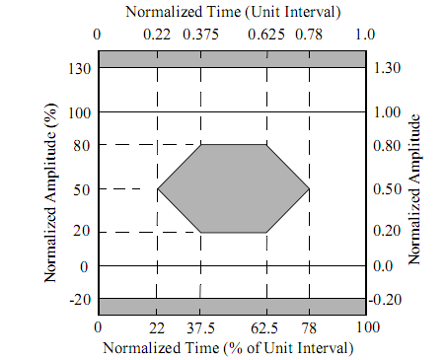
5
Specification of Receiver
Parameter | Symbol | Min. | Typ. | Max. | Unit | Note
Input Optical Wavelength | λIN | 1270 |  | 1610 | nm | APD
Receiver Sensitivity | PIN |  |  | -19 | dBm | Note (1)
Input Saturation Power (Overload) | PSAT | -3 |  |  | dBm
Los Of Signal Assert | PA | -40 |  |  | dBm
Los Of Signal De-assert | PD |  |  | -30 | dBm | Note (2)
LOS Hysteresis | PA-PD | 0.5 | 2 | 6 | dB
- Measured with Light source 1550nm, ER=9dB; BER =<10^-12 @PRBS=2^23-1 NRZ
- When LOS de-asserted, the RX data+/- output is High-level (fixed)
Electrical Interface Characteristics
Parameter | Symbol | Min. | Typ. | Max. | Unit | Note
Transmitter
Total Supply Current | ICC |  |  | A | mA | Note (1)
Transmitter Disable Input-High | VDISH | 2 |  | Vcc+0.3 | V
Transmitter Disable Input-Low | VDISL | 0 |  | 0.8 | V
Transmitter Fault Input-High | VTxFH | 2 |  | Vcc+0.3 | V
Transmitter Fault Input-Low | VTxFL | 0 |  | 0.8 | V
Receiver
Total Supply Current | ICC |  |  | B | mA | Note (1)
LOSS Output Voltage-High | VLOSH | 2 |  | Vcc+0.3 | V | LVTTL
LOSS Output Voltage-Low | VLOSL | 0 |  | 0.8 | V
Note:
6
- A (TX) + B (RX) = 500mA (Not include termination circuit)
Digital Diagnostic Functions
6
ETU-LINK ESDXX12-3LCD120 transceivers support the 2-wire serial communication protocol as defined in the SFP MSA. It is very closely related to the E2PROM defined in the GBIC standard, with the same electrical specifications.
The standard SFP serial ID provides access to identification information that describes the transceiver’s capabilities, standard interfaces, manufacturer, and other information.
Additionally, ETU-LINK SFP transceivers provide a unique enhanced digital diagnostic monitoring interface, which allows real-time access to device operating parameters such as transceiver temperature, laser bias current, transmitted optical power, received optical power and transceiver supply voltage .It also defines a sophisticated system of alarm and warning flags, which alerts end-users when particular operating parameters are outside of a factory set normal range.
The SFP MSA defines a 256-byte memory map in E2PROM that is accessible over a 2-wire serial interface at the 8 bit address 1010000X (A0h). The digital diagnostic monitoring interface makes use of the 8 bit address 1010001X (A2h), so the originally defined serial ID memory map remains unchanged. The interface is identical to, and is thus fully backward compatible with both the GBIC Specification and the SFP Multi Source Agreement.
The operating and diagnostics information is monitored and reported by a Digital Diagnostics Transceiver Controller (DDTC) inside the transceiver, which is accessed through a 2-wire serial interface. When the serial protocol is activated, the serial clock signal (SCL, Mod Def 1) is generated by the host. The positive edge clocks data into the SFP transceiver into those segments of the E2PROM that are not write-protected. The negative edge clocks data from the SFP transceiver. The serial data signal (SDA, Mod Def 2) is bi-directional for serial data transfer. The host uses SDA in conjunction with SCL to mark the start and end of serial protocol activation. The memories are organized as a series of 8-bit data words that can be addressed individually or sequentially.
Digital diagnostics for the ESDXX12-3LCD120 are internally calibrated by default.。
Host - Transceiver Interface Block Diagram

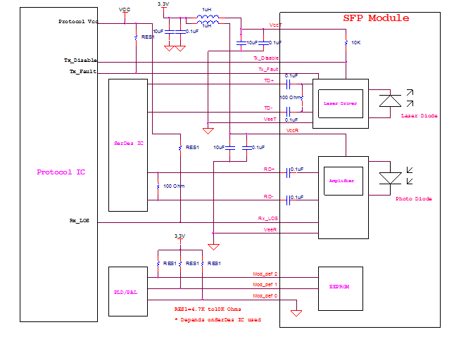
Outline Dimensions
7
6

Regulatory Compliance

Feature | Reference | Performance
Electrostatic discharge（ESD） | IEC/EN 61000-4-2 | Compatible with standards
Electromagnetic Interference (EMI) | FCC Part 15 Class B EN 55022 Class B (CISPR 22A) | Compatible with standards
Laser Eye Safety | FDA 21CFR 1040.10, 1040.11 IEC/EN 60825-1, 2 | Class 1 laser product
Component Recognition | IEC/EN 60950, UL | Compatible with standards
ROHS | 2002/95/EC | Compatible with standards
EMC | EN61000-3 | Compatible with standards

Ordering Information
8
Code | Frequency (THz) | Center Wavelength(nm) | Code | Frequency (THz) | Center Wavelength(nm)
C17 | 191.7 | 1563.86 | C40 | 194.0 | 1545.32
C18 | 191.8 | 1563.05 | C41 | 194.1 | 1544.53
C19 | 191.9 | 1562.23 | C42 | 194.2 | 1543.73
C20 | 192.0 | 1561.42 | C43 | 194.3 | 1542.94
C21 | 192.1 | 1560.61 | C44 | 194.4 | 1542.14
C22 | 192.2 | 1559.79 | C45 | 194.5 | 1541.35
C23 | 192.3 | 1558.98 | C46 | 194.6 | 1540.56
C24 | 192.4 | 1558.17 | C47 | 194.7 | 1539.77
C25 | 192.5 | 1557.36 | C48 | 194.8 | 1538.98
C26 | 192.6 | 1556.55 | C49 | 194.9 | 1538.19
C27 | 192.7 | 1555.75 | C50 | 195.0 | 1537.40
C28 | 192.8 | 1554.94 | C51 | 195.1 | 1536.61
C29 | 192.9 | 1554.13 | C52 | 195.2 | 1535.82
C30 | 193.0 | 1553.33 | C53 | 195.3 | 1535.04
C31 | 193.1 | 1552.52 | C54 | 195.4 | 1534.25
C32 | 193.2 | 1551.72 | C55 | 195.5 | 1533.47
C33 | 193.3 | 1550.92 | C56 | 195.6 | 1532.68
C34 | 193.4 | 1550.12 | C57 | 195.7 | 1531.90
C35 | 193.5 | 1549.32 | C58 | 195.8 | 1531.12
C36 | 193.6 | 1548.51 | C59 | 195.9 | 1530.33
C37 | 193.7 | 1547.72 | C60 | 196.0 | 1529.55
C38 | 193.8 | 1546.92 | C61 | 196.1 | 1528.77
C39 | 193.9 | 1546.12

9
Compatibility Test

In order to ensure the product compatibility, our products will be tested on the switch before shipment. Our modules can compatible with many mainstream brand switches, such as Cisco, Juniper, Extreme, Brocade, IBM, H3C, HP, Huawei, D-Link, Mikrotik, ZTE, TP-Link...

Our test equipment: VOLKTEK MEN-4110, HP 2530-8G, CRS226-24G-25+RM, Catalyst 2960G Series, Catalyst 3850 XS 10G SFP+, Catalyst 3750-E Series, HUAWEI S5700Series, H3C S3100V2 Series, Juniper-EX4200, etc.
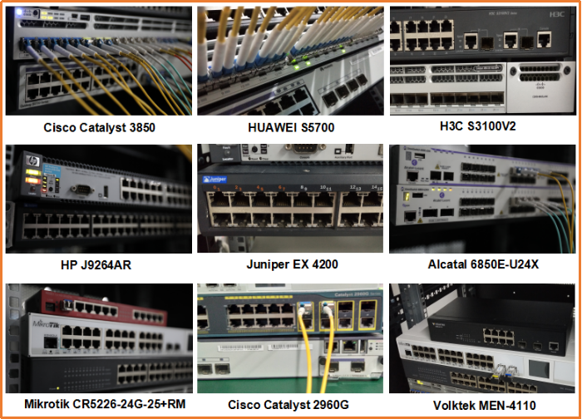

10
Product Production Process

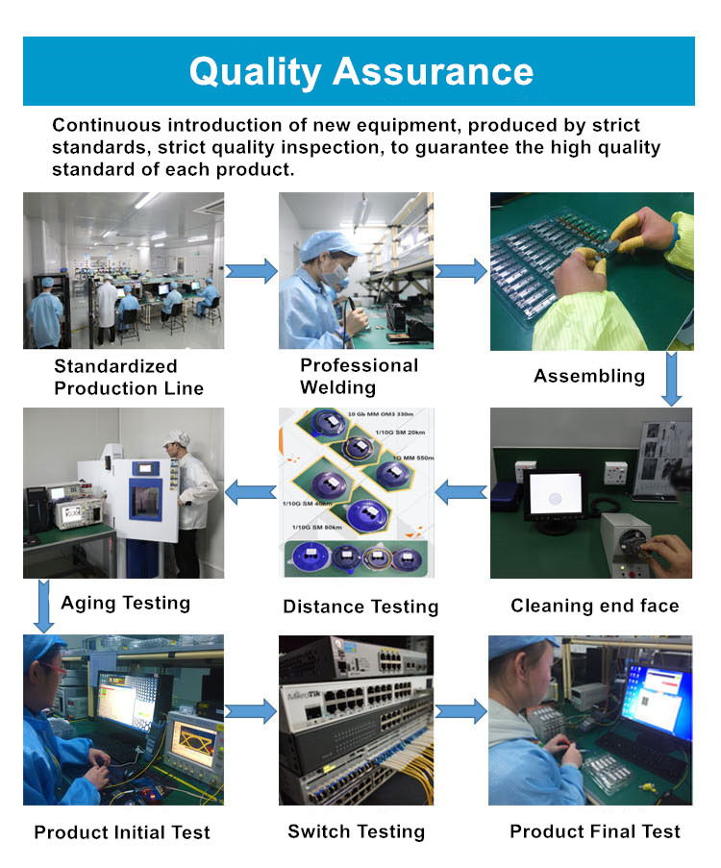

Packaging

11

ETU-Link provides two kinds of packaging, 10pcs/Tray and individual package.
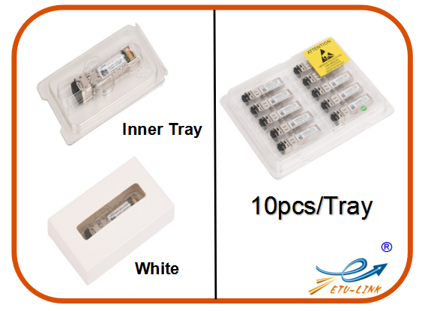

Company: ETU-Link Technology Co., LTD
Address: 4th Floor, C Building, JinBoLong Industrial Park, QingQuan Road, LongHua District,
Shenzhen city, GuangDong
Tel: +86-755 2328 4603

Addresses and phone number also have been listed at www.etulinktechnology.com.
Please e-mail us at sales@etulinktechnology.com or call us for assistance.

Fiber Optic Transceivers Copyright 2011—2017 etulinktechnology.com All Rights Reserved

